Acknowledgements

Our appreciation goes to ***Engr Ibrar*** for guiding us through the project and to our colleagues of BEE-12D for their support. Special thanks to **Dr Arbab Latif**, all the YouTube channels such as RFID tutorials and ***Alsan Palaguli[1]*** for clarifying our doubts against the local sever all its settings. In the end how can we forget our assistive seniors for providing us all the guidelines. As our project is basically consists of the sequential circuits so which is the last part of our semester it was a difficulty to make a project using the last concepts of the course so during various datasheets and open-source papers and platforms helped us a lot and we are abled to build a full flash project with the local server and its setting.

Literature Review:

Radio frequency identification (RFID) is a prominent technology for a wide array of applications, from inventory tracking to payment processing. In the field of security, RFID door lock systems are utilized for access control, as they provide a reliable, consistent experience with trackable data. To function efficiently, an RFID door locking system requires RFID tags, antennas, an RFID reader, and a transceiver. In this system, the user's credential (usually a keycard or fob with an RFID chip) contains unique identifying information called a tag. Each RFID (Radio Frequency Identification Device) tag has a unique value. By doing this project we able to understand how to interface different modules with the atmega16A and how we can form our own simple microprocessor. This project is simple the advancement of the door locking system. As in this we used the database by using the Wi-Fi module and store the information of the cards that enter through this RFID sensor. Although we are facing some difficulties in interfacing the Arduino with the RFID MRC522, though this major problem is solved by consulting the NodeMCU which is responsible for setting up the local host with the PHP and MySQL database environment on our PC using the XAMPP platform.

Introduction:

This project is basically to control the door using the RFID Card module so that there is no external interference and in addition to that we must send data to the external local server using the XAMPP as for local server we have to set the PHP and the MySQL library in our PCs due to which we are using the XAMPP platform. So far, we have used the HTML, PHP and the AVR C programming to setup the RFID with the external server. By using the server we can register whether it is registered or not registered, so that we have 2 security check points the one thing is using the server and the other is by scanning the card and door will opens clearing the path.

Description of Different Modules:

|  |  |
| --- | --- |
| * Atmega 16A | * LED Lights |
| * RFID Module MRC522 | * Potentiometer |
| * LCD 16X2 Display | * Servo Motor |
| * NodeMCU ESP8266 Wifi Module | * Breadboard & Jumper Wires |
|  |  |

RFID MODULE MRC522:

The RC522 is a 13.56MHz RFID module that is based on the MFRC522 controller from NXP semiconductors. The module can support I2C, SPI and UART and normally is shipped with a RFID card and key fob. It is commonly used in attendance systems and other person/object identification applications.

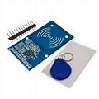

NODE MCU ESP8266 Wifi MODULE

NodeMCU is an open source platform based on ESP8266 which can connect objects and let data transfer using the Wi-Fi protocol. In addition, by providing some of the most important features of microcontrollers such as GPIO, PWM, ADC, and etc. it can solve many of the project’s needs alone.

The general features of this board are as follows:

* Easy to use
* Programmability with Arduino IDE or IUA languages
* Available as an access point or station
* practicable in Event-driven API applications
* Having an internal antenna
* Containing 13 GPIO pins, 10 PWM channels, I2C, SPI, ADC, UART, and 1-Wire

Software Used:

|  |  |
| --- | --- |
| * XAMPP (For local Server) | * Atmel Studio |
| * Arduino IDE | * Proteus |
|  |  |

XAMPP:

In a nutshell, [XAMPP](https://www.apachefriends.org/index.html) is a local server that you can install on your laptop/desktop to mimic an actual web server.

It’s a completely free, open source Apache server distribution with MariaDB (formerly MySQL), PHP, and Perl. XAMPP is available for all major operating systems, and is extremely easy to install and use. This explains why it’s the most popular PHP development environment.

MYSQL:

MySQL is an open source SQL relational database management system that’s developed and supported by Oracle.

MySQL opts for an approach called a relational database.

With a relational database, your data is broken up into multiple separate storage areas – called tables – rather than throwing everything together into one big storage unit.

 

Block Design:

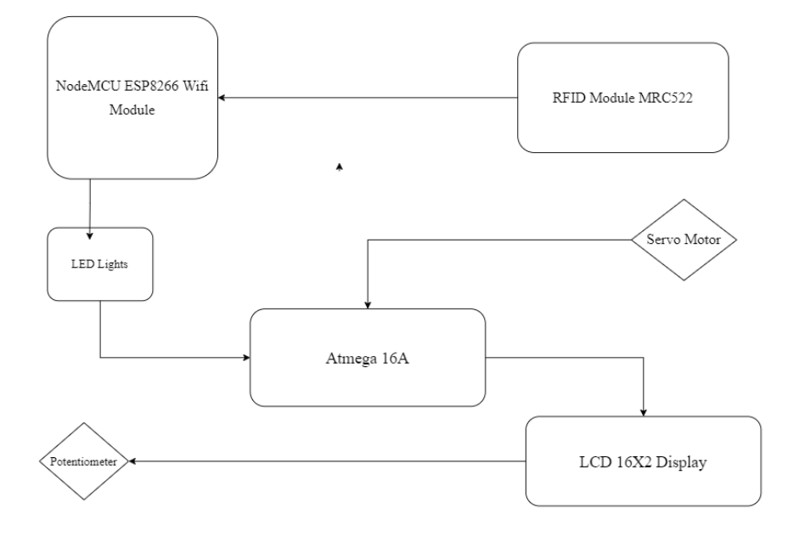

Precautionary Measure:

***Basic operating conditions of the system:***

● Normal operating temperature - 25 ℃

● Supply voltage - 5V

● Listed parts in the previous text

***System safety requirements:***

● Do not expose to water surfaces

● Do not expose to high voltage

● Do not expose to high temperatures

● Do not expose to strong compressive forces

● It is necessary to separate the parts from each other

● Avoid damage to the equipment

Design Methodogy:

***Connection Between NodeMCU and RFID Reader***

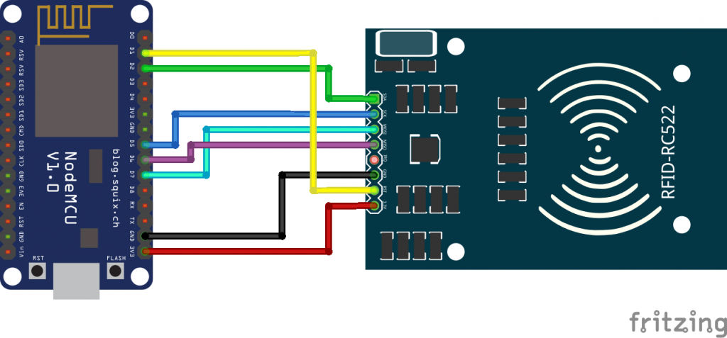

RFID is connected with the NodeMCU to send the data to the atmega so that we can add the necessary instruction to the Atmel so that the door will open if an intruder enter with the card the alarm will clock.

***Connection Between Servo Motor and Atmega16A***

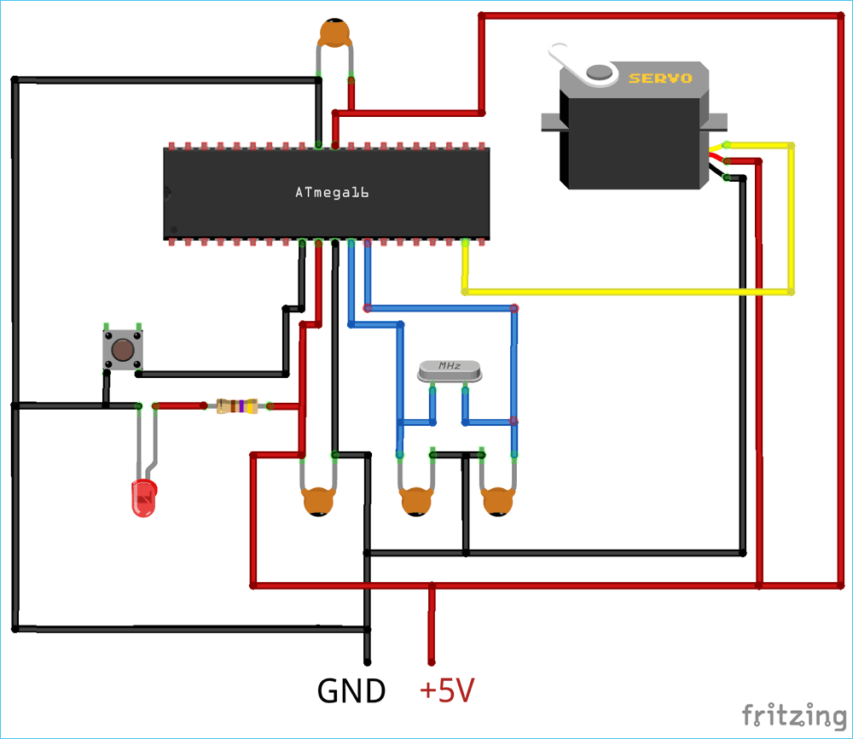

As when the NodeMCU sent the signal to the Atmega16A, the atmega16 done the computational analysis so that the specific operation can be made regarding the opening of the door using the servo motor.

Local Host SnapShots:

***Home:***

***User Data:***

***Read UID Tag:***

Hardware Picture With Reader Module:

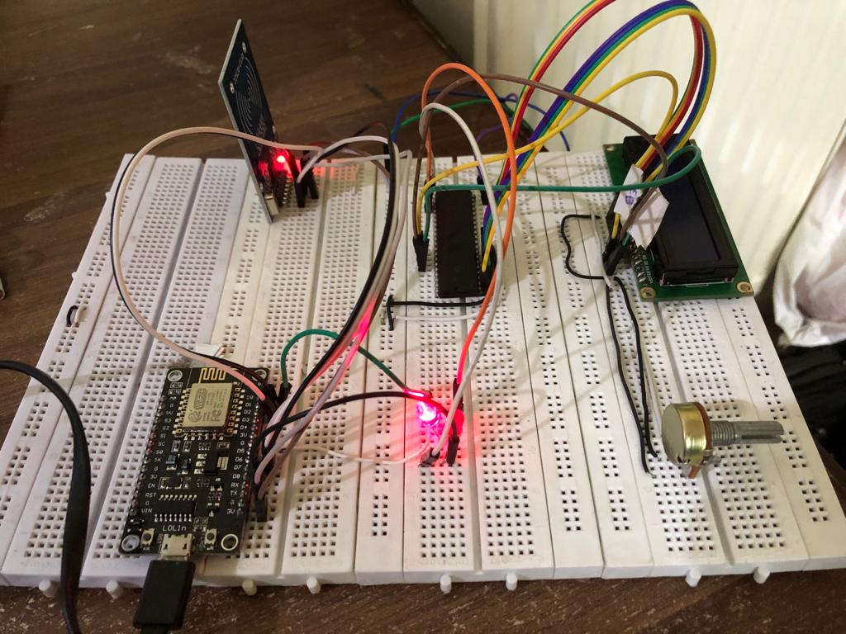

This is the circuit without the external door.

Simulation:

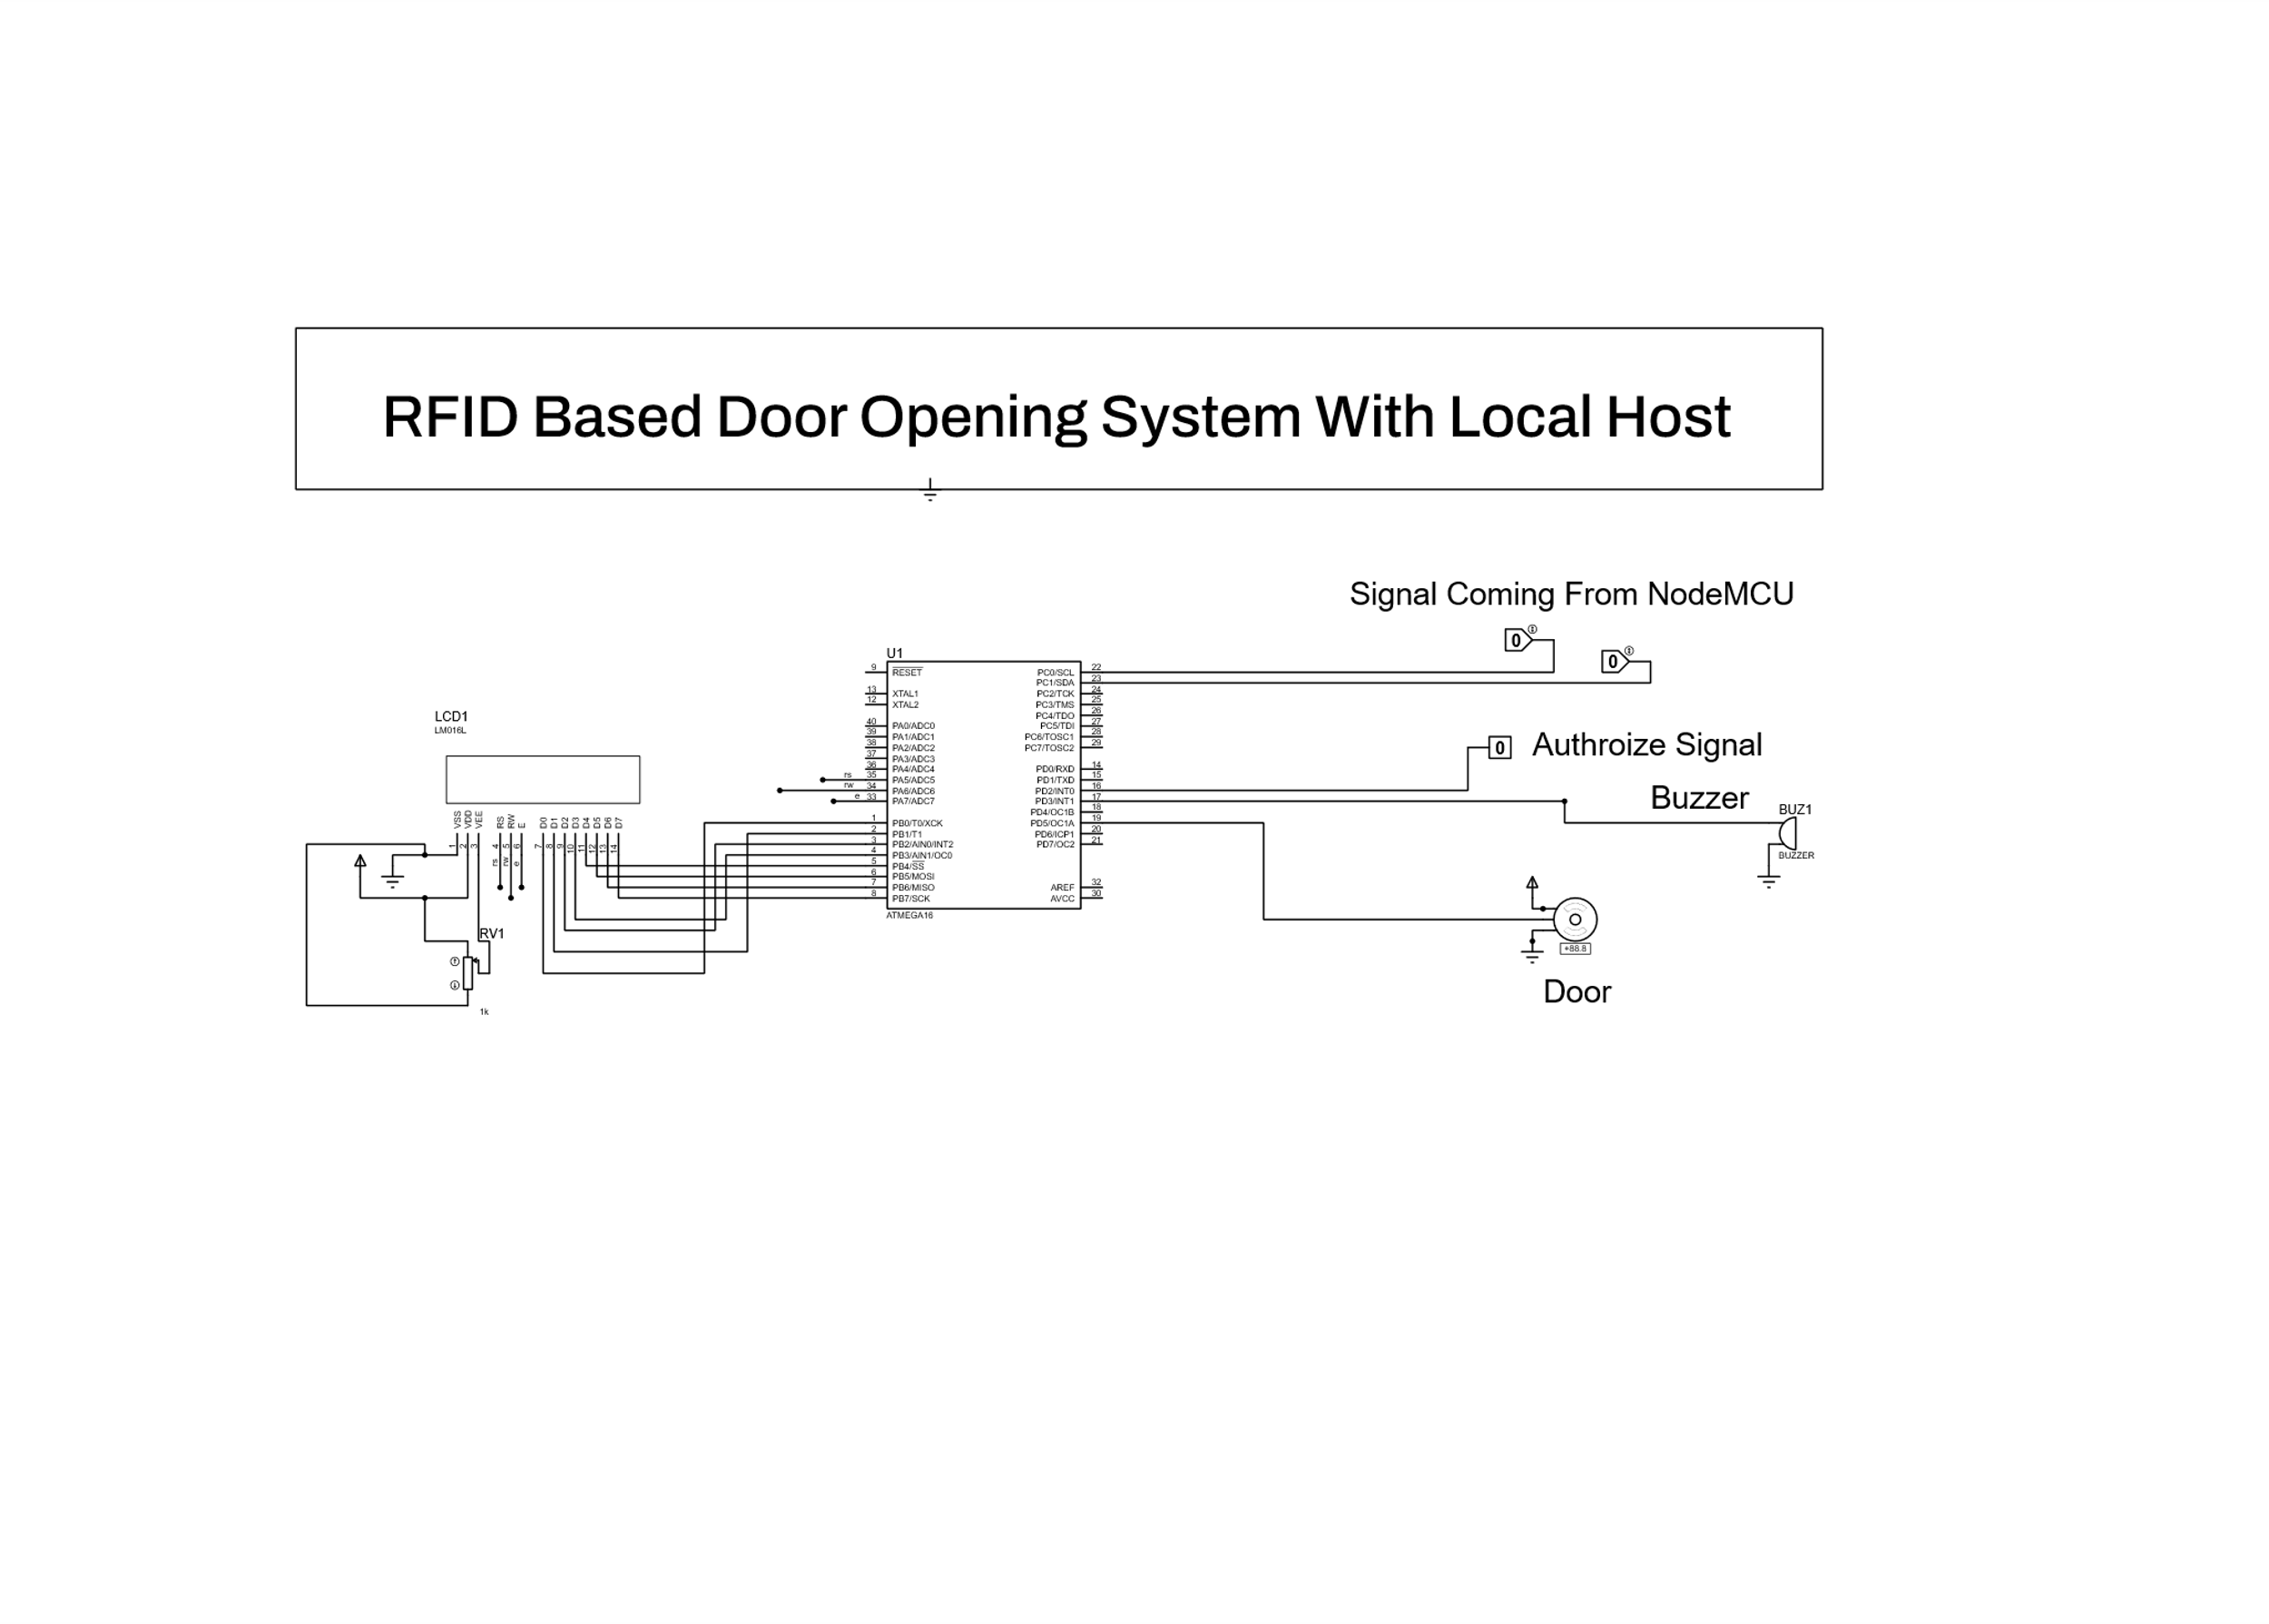

Future Recommendations:

Use the general RFID EM-1 Module.

All the computational analysis will be done Atmega16a.

Use more powerful and secure server for long distance security.

Various ports can be made for external use by increasing the external circuitry.

Conclusion:

Radio frequency identification (RFID) is a prominent technology for a wide array of applications, from inventory tracking to payment processing. When it comes to security, RFID door lock systems are very common for access control, as they provide a reliable, consistent experience with trackable data. Unlike other forms of traditional access control such as swipe cards, RFID locking systems are contactless, meaning that the credential doesn’t have to touch the reader for it to work.

References:

Atmel - ATMega16A datasheet

● MFRC522 Contactless reader IC datasheet -

https://www.hobbytronics.co.uk/datasheets/sensors/MFRC522.pdf

https://www.hobbytronics.co.uk/mfrc522-reader

https://www.avrfreaks.net/forum/rfid-rc522-spi-and-atmega32a-initialisation https://randomnerdtutorials.com/security-access-using-mfrc522-rfid-reader-with-arduino/ https://github.com/miguelbalboa/rfid

https://github.com/asif-mahmud/MIFARE-RFID-with-AVR/tree/master/lib ● SPI - http://maxembedded.com/2013/11/the-spi-of-the-avr/

http://avrbeginners.net/architecture/spi/spi.html

https://www.electronicwings.com/avr-atmega/atmega1632-spi

http://www.firmcodes.com/microcontrollers/avr/spi-interfacing-with-atmega16/

[GitHub - SvenCelin/NFC-doorlock---atmega-16a: This project is made for Atmega 16a and Atmega 32.](https://github.com/SvenCelin/NFC-doorlock---atmega-16a)

***The End***

1. [RFID-Attendance-system-V2.0/rfidattendance at master · InfinityWorldHI/RFID-Attendance-system-V2.0 · GitHub](https://github.com/InfinityWorldHI/RFID-Attendance-system-V2.0/tree/master/rfidattendance)